**How to Use Template**

**FanBase Blogger Template**

**Contact Us :**

**Facebook :** [**http://www.facebook.com/cmon.frozen**](http://www.facebook.com/cmon.frozen?ref=tn_tnmn)

**Link Blog : cmonfrozen.blogspot.com**

**Edit Meta Tag**

1. Go to Blogger.com log in your account blog
2. Your Blog > Template > Edit Html
3. Find (CTRL + F)

<meta content='KEYWORDS' name='keywords'/>

<meta content='DESCRIPTION' name='description'/>

* Change **Keywords** with your keywords blog

Example : fansubs, watch anime, fansubs subtitle English, etc

* Change **Description** with your description blog

Example : Fan Base Free Watch Anime Subtitle English

**Edit Meta Tag Author**

1. Go to Blogger.com log in your account blog
2. Your Blog > Template > Edit Html
3. Find (CTRL + F)

<link href='https://plus.google.com/**116641703883154535771'** rel='me'/>

<link href='https://plus.google.com/**116641703883154535771**/about' rel='author'/>

<link href='https://plus.google.com/**116641703883154535771**/posts' rel='publisher'/>

* Change **116641703883154535771** with your id google plus

Example : fansubs, watch anime, fansubs subtitle English, etc

**Valid Html5**

1. Find and Delete this below Html

<b:include name='quickedit'/>

2. add ALT and Title in your Images

<img src=**’exampleurlimage’** alt=’post title’ title=’post title’ />

**SEO Heading**

1. Find this below Html

**<h2 class='title'><data:title/></h2>**

And replace with this code

**<h3 class='title'><data:title/></h3**

**Disable Costum Template for Mobile**

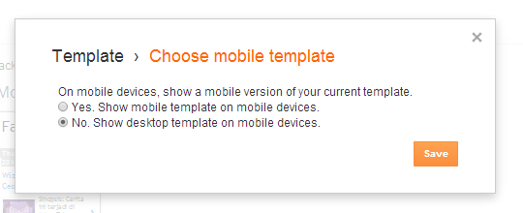

# Language and formatting

# C:\Users\OPERATOR\Downloads\Template\AnimePlus\Languange And Formatting.JPG

# Show your profile image in index google

# G:\img.PNG

1. Open your Google Plus [[here](http://plus.google.com/me)]

2. Click **About (**[**https://plus.google.com/idgoogleplus/about**](https://plus.google.com/idgoogleplus/about)**)**

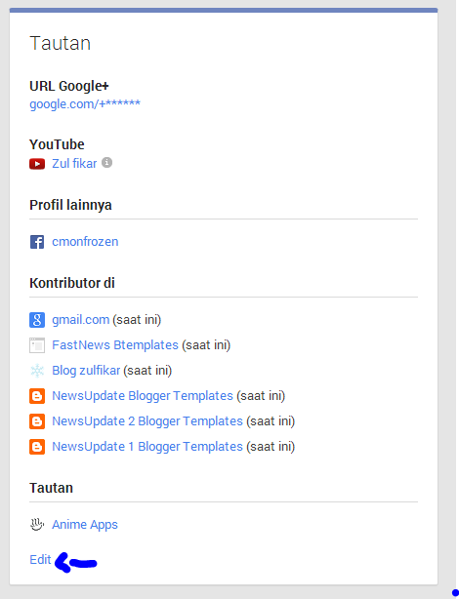

3. Click [**Edit**] then scroll.. and see like **Contributors in** or **Kontributor di**

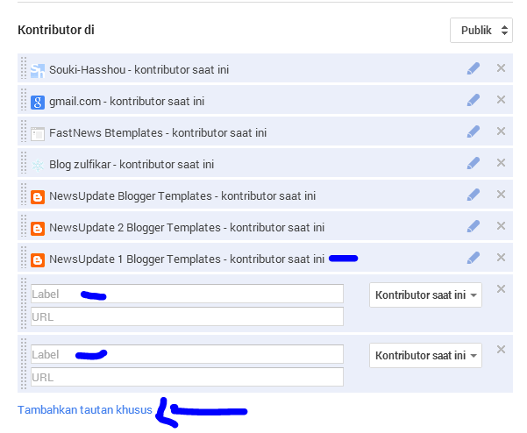

4. Click **add a special link** or **tambahkan tautan khusus**

# Edit Resolution Image Post

1. Find html like below html

function resizeThumb(parentID, size) {

var parent = document.getElementById(parentID),

image = parent.getElementsByTagName('img');

for (var i = 0; i < image.length; i++) {

image[i].src = image[i].src.replace(/\/s72\-c/, "/s" + size + "-c");

image[i].width = size;

image[i].height = size;

}

}

resizeThumb(**'main-wrapper'**, **100**);

**Red Text : class elements**

**Blue Text : Size Resolution (Width x Height)**

**PREVIEW**

